# What is Git

It is version control system. How it works:

## Mecanism

Initially all files are copied. Thereafter files are changed. In version 1 the changed files are only copied. Then in version 2 again changed files are copied. The link of unchanged files are there. So each version is a snapshot comprising of link of unchanged files and intact changed files. An internal database is maintained. Files are compared using checksum which is SHA-1 algorithm.

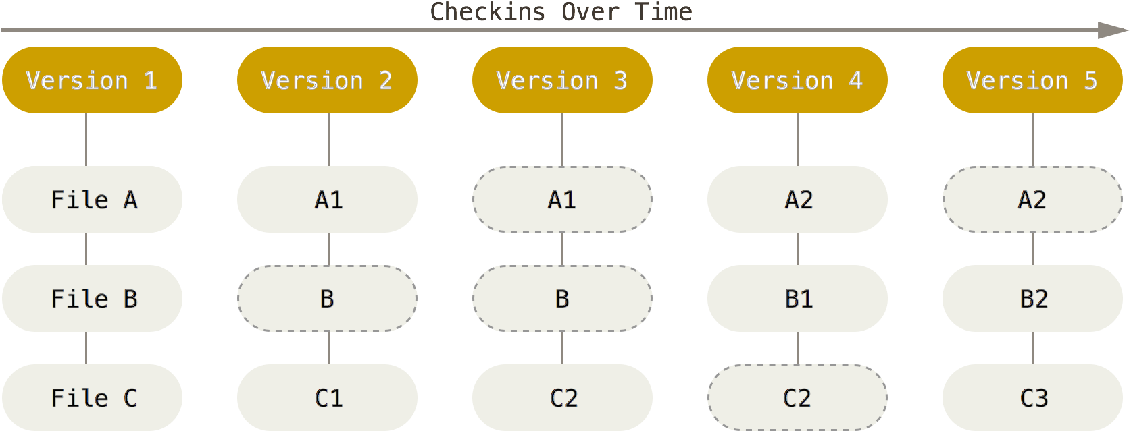

It has become a mini file system instead of a VCS. There is three state of git files.

1. Committed: Git Directory: Safely stored in GIT database
2. Modified: Working directory: You have made some changes but not committed
3. Staged: Staging area: Ready to be saved in GIT database.

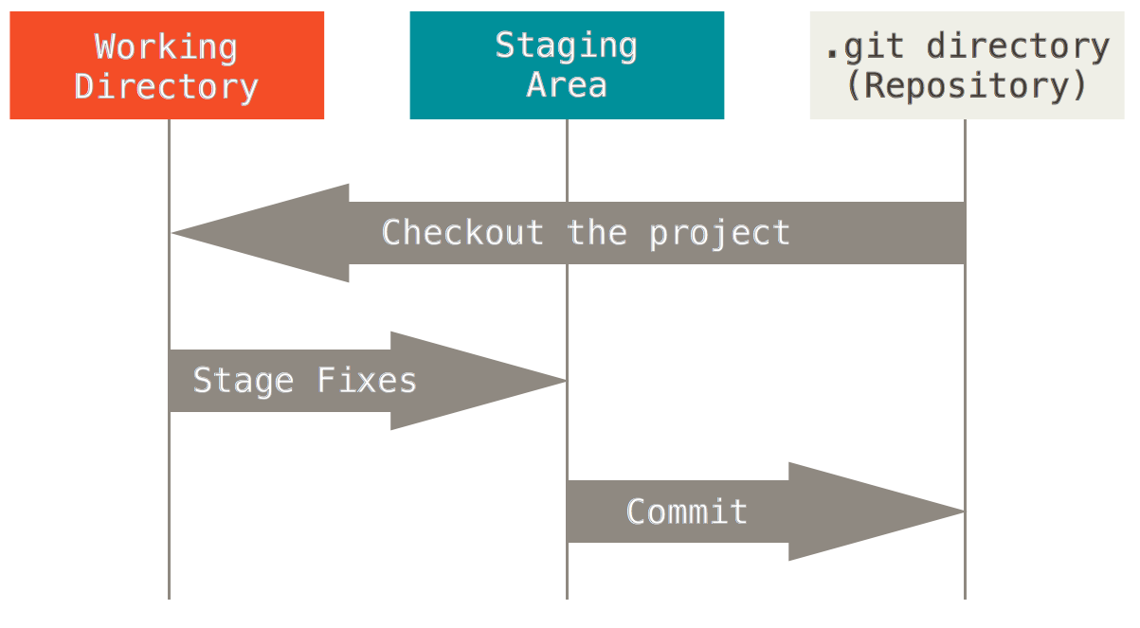

Git command line is super subset of all GUI’s.

# Git cli commands

git help config

git config –global user.name “sushant” //will set user name

# Working with Git

Go in a directory which you want to track

Git init

Git add *.*

Git commit –m “initial version”

You will see a .git hidden folder which will have all compressed files.

You must do configuration for your default editor.

Git config –global core.editor “subl –w”

This makes sublime text default editor and let git watch when you finish editing during commit.

To clone a directory from a server

Git clone url

The url can also have a file path

Git clone f:\learning\something myCopy

Will copy all files to myCopy.

Git status

Will show the status of each file in current directory.

Git commit

Will do commit the tracked files. It will open the default editor registered with git.

In brief with these minimum commands you can start git:

Git init, git configure, git add –A, git commit.